**THE INFLUENCE OF USING POWTOON AND READING HABITS TOWARD STUDENTS’ READING COMPREHENSION ACVIEVEMENT AT SMK UTAMA BAKTI PALEMBANG**

**A THESIS**

**Submitted to the Graduate Program**

**In Partial Fulfillment of the Requirement for the Degree of**

**Magister *Pendidikan* (M.Pd) in English Language Education**

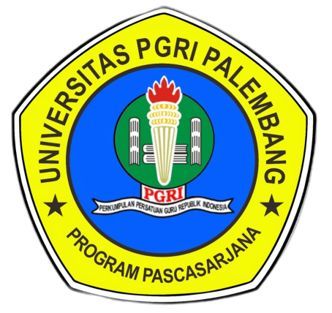

**By:**

**DICKY ANDRIAN**

**Student Registration Number :** 20226012020

**ENGLISH EDUCATION STUDY PROGRAM**

**GRADUATE PROGRAM**

**PGRI UNIVERSITY OF PALEMBANG**

**2024**