THE USE OF THE CHAT GPT APPLICATION AS A SUPPORTING TOOL IN LEARNING ENGLISH GRAMMAR

Thesis by:

Firli Putri Andira

Student Identification Number 2020111033

English Education Study Program

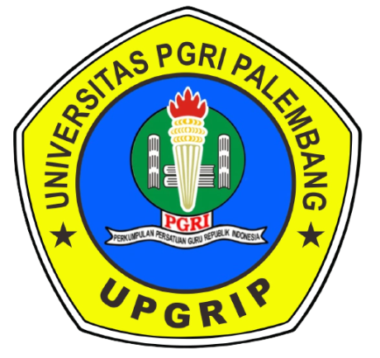

FACULTY OF TEACHER TRAINING AND EDUCATION

PGRI UNIVERSITY OF PALEMBANG

2024

